**COLOHR FEST 2015 POSTER ENTRY FORM**

Artist’s name: _________________________________________________________

Address: _____________________________________________________________

City: ____________________________ ST:_______ Zip: _____________________

Email: _______________________________________________________________

Home or Office Phone: _____________________ Mobile: _____________________

Brief biography: (use back if necessary) ___________________________________

________________________________________________________________________________________________________________________________________

**THIS FORM MUST  
ACCOMPANY YOUR ENTRY!**

**If shipping, mail to:**  
Poster Contest  
Ohr-O’Keefe Museum of Art  
386 Beach Boulevard  
Biloxi, MS 39530

**Or deliver to:**  
OOMA Welcome Center  
Tues-Sat, 10am to 5pm

**Deadline March 2, 2015**

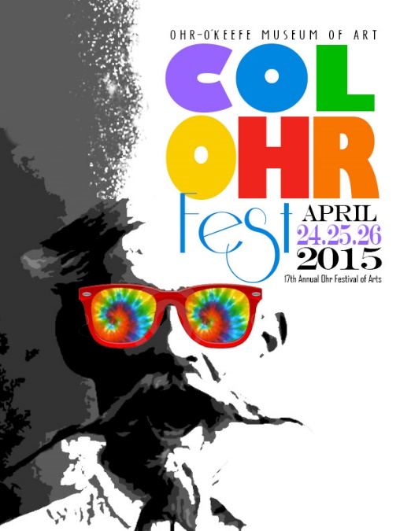

Ohr-O’Keefe Museum of Art  
ColOhr Fest  
April 24-26, 2015  
  
**Mailing Address:**Post Office Box 248  
Biloxi, MS 39533-0248

**Phone**: 228.374.5547  
**Fax:** 228.436.3641  
**Email:** admin@georgeohr.org

Admission: $5 Adults  
FREE children 12 & under

Friday – 5pm to 9pm  
Saturday – 9am to 8pm  
Sunday – 10am to 6pm  
  
[www.georgeohr.org](http://www.georgeohr.org)  
facebook.com/OhrOkeefeMuseumOfArt

**2015 ColOhr Fest Poster Contest  
Sponsored by The City of Biloxi**

**$300 Cash Award**

* Deadline for submissions is 5 pm, March 2, 2015 at the Museum, 386 Beach Blvd, Biloxi MS
* The poster design must celebrate George’s life and/or artwork and reflect Ohr’s innovative, independent, and creative spirit.
* The contest is open to those 18 and over.
* All artwork must be original, produced and signed by the artist.
* Each artist may submit only one piece of work.
* All appropriate media, including original computer-generated images, must be submitted in a two-dimensional format and signed by the artist. All entries must be camera ready.
* Entries must be 14” x 16” and may be horizontal or vertical.
* Text may be integrated with the work.
* Submitted work must be delivered on or attached to a firm surface and protected with acetate or clear plastic.
* Entries must include a typed or printed entry form, attached to the back
* OOMA will retain the rights to the artwork and any duplication thereof.
* The Festival Committee will serve as judges; all decisions are final.
* Notification will be made within 72 hours of judging.
* The winning artist must agree to attend the festival Saturday and Sunday for two hours each day to sign posters.
* The winning artist will receive $300, 20 posters and four festival T-shirts.   
    
  **For questions regarding this contest, contact:** Trish Lawrence

[admin@georgeohr.org](mailto:admin@georgeohr.org) or call 228-374-5547